This is an anonymous survey.  Please do not sign your name. | 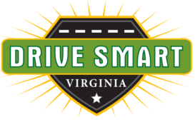
Your employer is conducting an anonymous survey to determine whether employees are aware of the dangers of distracted driving. Please answer the following questions honestly, then submit this form as directed.

Distracted Driving Survey

In Virginia, a police officer can pull you over for texting-while-driving.
 | True |  | False |  | Only if the officer believes I’ve committed another offense (like speeding).

Complete the sentence: “While driving, I use my smartphone to…”
 | make calls. |  | make calls & check email or texts. |  | make calls, check email, text & use social media. |  | I don’t use my phone while driving.

How often do you place or receive calls while driving?
 | Never |  | Sometimes |  | Most of the time |  | Always

Placing a hands-free call or using speech-to-text apps behind the wheel is not distracted driving.
 | True |  | False

I’ve seen a member of my company’s management team use a phone while driving.
 | True |  | False

My company has a cell phone policy.
 | True |  | False |  | Not Sure

It irritates me when I see someone texting-while-driving.
 | True |  | False |  | Depends on the Situation

It’s okay to text or check social media while sitting at a stoplight.
 | True |  | False

An employer can be held responsible if an employee injures someone due to distracted driving.
 | True |  | False
Thank you very much for taking the time to complete this survey.

