Sample 4th of July Facebook/Instagram Posts:

Independence Day is right around the corner! As you gear up to celebrate our nation’s birthday, we want to remind you to have a plan on how to get home safely. Designate a sober driver, use public transportation, or use a ride sharing service. ENJOY the holiday. Stay safe and live on for yourself and your loved ones. #designateB4Ucelebrate
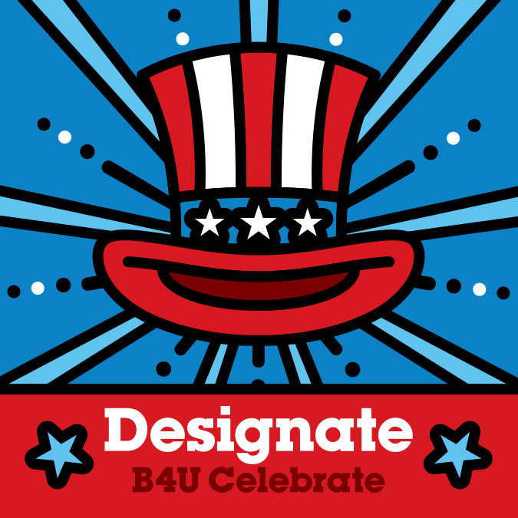

4th of July is here! We expect many Virginians to be out enjoying the holiday with family and friends. Stay alert and focused on the roads. PLEASE follow the speed limit, and drive distraction free and sober. Set a good example for those in your family by buckling up. ENJOY the holiday and stay safe! #designateB4Ucelebrate

