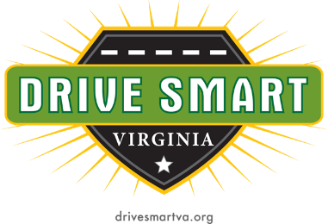

World Day of Remembrance for Road Traffic Victims Media Event

Who: Families of crash victims, crash survivors, DRIVE SMART Virginia, Virginia DMV, and Chesapeake Region Safety Council

What: Media awareness event to remember those impacted by preventable roadway crashes with a call to action urging the public to drive with more care for others on the roads.

When: November 15, 2024 at 10am

Where: Hollywood Cemetery – at the James River Overlook Chapel/Mausoleum
412 South Cherry Street
Richmond, VA 23220
*Please DO NOT park on any grass areas of the cemetery!

Contact: Kristin Pettway, Executive Director of DRIVE SMART Virginia
276-206-6963 (cell)
Kristin.pettway@drivesmartva.org

