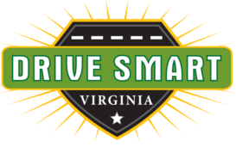
DISTRACTED DRIVING AWARENESS MONTH

ACTIVITIES AND IDEAS FOR EMPLOYERS

April is Distracted Driving Awareness Month. It’s against the law in Virginia to hold a handheld communications device while operating a moving motor vehicle. Help spread the word!

Here are some suggested tweets. Please tag us: @DriveSmartVA

• 🚫 Nothing on your 📱 is more important than what’s in front of your 🚗. #DDAM
• April is Distracted Driving Awareness Month. What do you habitually do while driving that you shouldn’t? 🤔🚗
• Imagine how your driving would improve if your 👀 never wandered to your 📱. April is Distracted Driving Awareness Month. #PhoneDown 🚗💡
• A distracted driver can be as dangerous as a drunk driver. April is Distracted Driving Awareness Month. #PhoneDown 🚫 📱🚗
• The only instant message you should send while driving is a turn signal! 🚗 April is Distracted Driving Awareness Month. #DDAM
• April is Distracted Driving Awareness Month. Do you know it’s illegal to hold a 📱 while driving in Virginia? 🚔#DDAM
• 📱 Texting while driving increases your likelihood of being involved in a crash by 23 times! 🚗💥📵 April is Distracted Driving Awareness Month.
• Are you reading this tweet while driving? #Busted 🤭🚗🚨 April is Distracted Driving Awareness Month.
• The average text takes 5 seconds – At 60 MPH, it’s like driving the length of a football field while blindfolded! April is Distracted Driving Awareness Month. 🏈🚗💨

