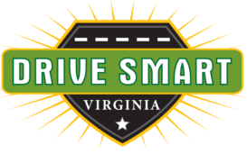
DISTRACTED DRIVING AWARENESS MONTH

ACTIVITIES AND IDEAS FOR EMPLOYERS

Make It Fun!
Employees are more likely to embrace a safety program when they are part of the process. Make it fun! Have a poster or slogan contest between departments. Provide a prize for the winner.

Share the Message
Posters and pamphlets are available – free – from the DRIVE SMART Virginia Online Store at https://www.drivesmartva.org/store/. We’ll even ship them to you. A distracted driving awareness display in a break room, or other area employees will regularly see it, will spread the message and demonstrate your company’s commitment to safe driving habits.

Spread the Word
Add a traffic safety message about distracted driving to your email signature and/or website. Suggestion: “April is Distracted Driving Awareness Month. Put the phone down and just drive!”

Keep It Real
Conduct an anonymous survey of employees’ driving habits. Conduct one survey at the beginning of April and another at the end of the month. Share the results with employees in an email or newsletter. You can use the “poll” feature on X (formerly Twitter) to conduct your survey.

Make a Day of It
Plan an employee safety day. Invite your local fire and police departments to participate. Contact local organizations like DRIVE SMART Virginia and invite them to table at your event.

Walk the Walk
Institute a company-wide policy regarding cell phone use. DRIVE SMART Virginia recommends a ban on the use of all handheld devices while operating a vehicle in connection with employment. This includes commuting to or from work.
For most workers, the daily commute is the most dangerous part of the workday. Let’s make traffic safety a top priority!

